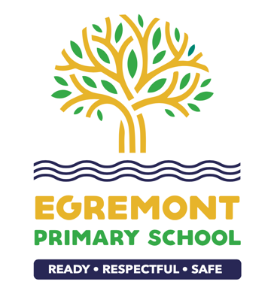
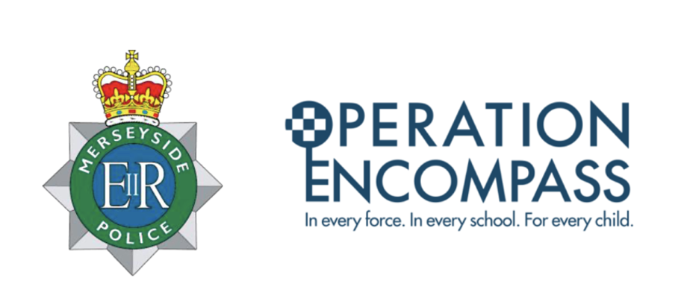

Our Key Adults are Mrs Eastwood, Miss Flynn, Miss Merry, Miss Hoey and Mrs Wakefield.

Operation Encompass
Our school is part of Operation Encompass. This is a police and education early intervention safeguarding partnership that supports children and young people who experience Domestic Abuse.
Operation Encompass means that the police will share information about Domestic Abuse incidents with our school PRIOR to the start of the next school day when they have been called to a domestic incident.

