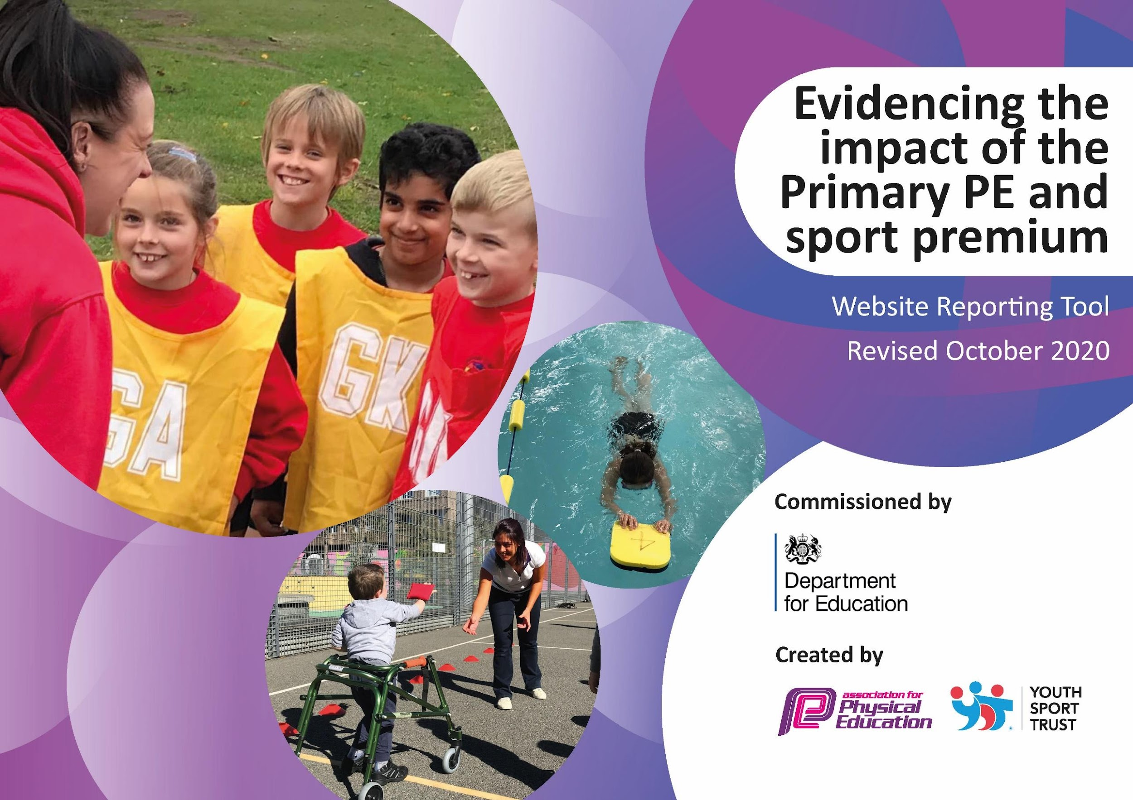
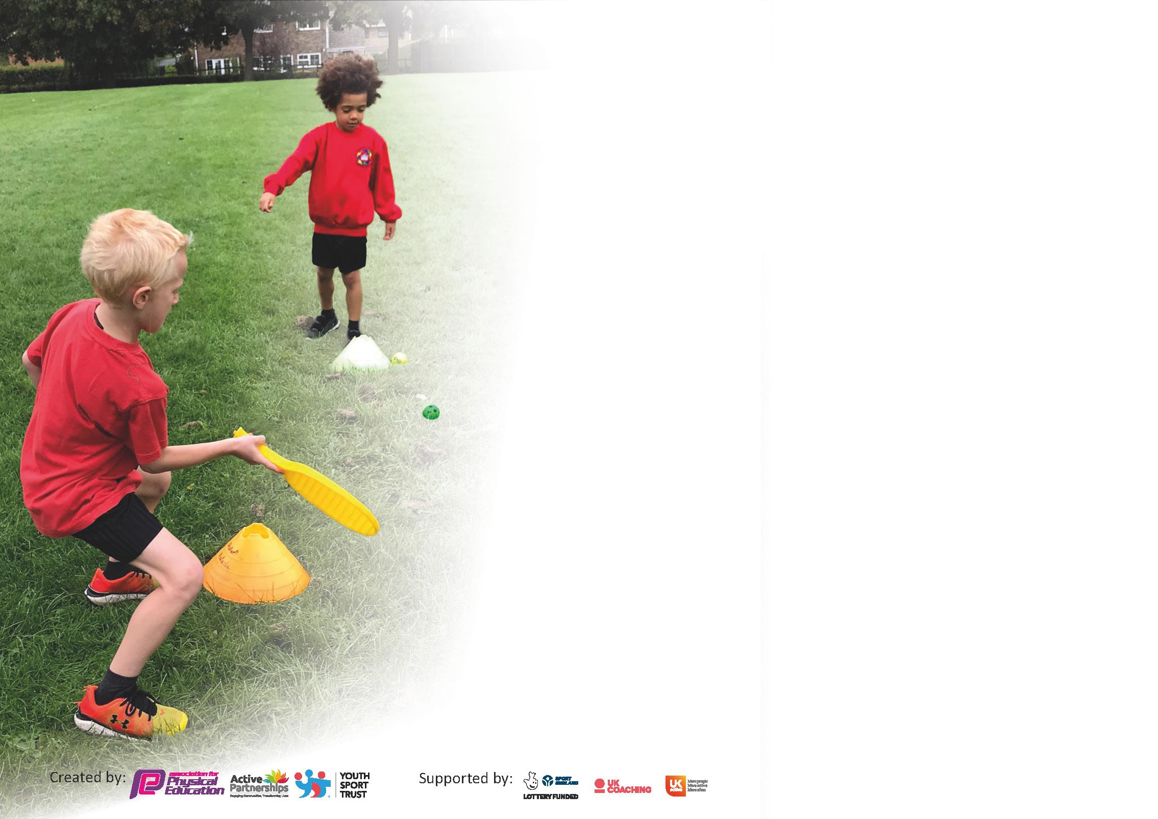

It is important that your grant is used effectively and based on school need. The Education Inspection Framework (Ofsted 2019 p64) makes clear there will be a focus on ‘whether leaders and those responsible for governors all understand their respective roles and perform these in a way that enhances the effectiveness of the school’.

Under the Quality of Education criteria (p41) inspectors consider the extent to which schools can articulate their curriculum (INTENT), construct their curriculum (IMPLEMENTATION) and demonstrate the outcomes which result (IMPACT).

To assist schools with common transferable language this template has been developed to utilise the same three headings which should make your plans easily transferable between working documents.

Schools must use the funding to make additional and sustainable improvements to the quality of Physical Education, School Sport and Physical Activity (PESSPA) they offer. This means that you should use
the Primary PE and sport premium to:

- Develop or add to the PESSPA activities that your school already offer
- Build capacity and capability within the school to ensure that improvements made now will benefit pupils joining the school in future years

Please visit gov.uk for the revised DfE guidance including the 5 key indicators across which schools should demonstrate an improvement. This document will help you to review your
provision and to report your spend. DfE encourages schools to use this template as an effective way of meeting the reporting requirements of the Primary PE and sport premium.

We recommend you start by reflecting on the impact of current provision and reviewing the previous spend.

Schools are required to publish details of how they spend this funding as well as on the impact it has on pupils’ PE and sport participation and attainment by the end of the summer term or by 31st July 2021 at the latest.

** In the case of any under-spend from 2019/20 which has been carried over this must be used and published by 31st March 2021.

We recommend regularly updating the table and publishing it on your website throughout the year. This evidences your ongoing self-evaluation of how you are using the funding to secure maximum, sustainable impact. Final copy must
be posted on your website by the end of the academic year and no later than the 31st July 2021. To see an example of how to complete the table please click HERE.
Created by: Supported by:

Please note: Although there has been considerable disruption in 2020 it is important that you publish details on your website of how you spend the funding - this is a legal requirement.

Support for review and reflection - considering the 5 key indicators from DfE, what development needs are a priority for your setting and your pupils now and why? Use the space below to reflect on previous spend and key achievements and areas for development.

N.B. In this section you should refer to any adjustments you might have made due to Covid-19 and how these will influence further improvement.
Key achievements to date until July 2021: | Areas for further improvement and baseline evidence of need:
A£2000 equipment order  Equipment audit to rag rate what equipment we need next  After school and lunch time clubs were started  Football team was created  Started staff CPD with Break the mould and Rugby coach  Playground quotes  Wirral overviews have been adapted to meet Egremont’s needs  Risk assessments for all sports completed | Staff CPD  Established timetables of when PE is taught in all year groups  Continue to add to resources bought in 2020 to enable staff to teach a range of sports  After school sports clubs  Playground safety  Ensure program of staff CPD

Did you carry forward an underspend from 2019-20 academic year into the current academic year? YES/NO * Delete as applicable

If YES you must complete the following section
If NO, the following section is not applicable to you
If any funding from the academic year 2020/21 has been carried over you MUST complete the following section. Any carried over funding MUST be spent by 31 March 2021.
Academic Year: September 2021 to July 22 | Total fund carried over: | Date Updated:
What Key indicator(s) are you going to focus on?  Your school focus should be clear how you want to impact on your pupils.  The engagement of all pupils in regular PE.  Increased confidence, knowledge and skills of all staff in teaching PE and sport  Broader experience of a range of sports and activities offered to all pupils  Increased participation in a competitive sport |  |  |  | Total Carry Over Funding:
Intent | Implementation |  | Impact
The engagement of all pupils in regular PE.  Increased confidence, knowledge and skills of all staff in teaching PE and sport  Broader experience of a range of sports and activities offered to all pupils  Increased participation in a competitive sport | Fit Fridays and another PE sessions throughout the week  Rugby coach, Running Head first and Break the Mould support with whole school CPD and supporting staff to teach PE effectively  Having the resources there in order to deliver all sessions  Start after school clubs | Carry over funding allocated: | Evidence of impact: How can you measure the impact on your pupils; you may have focussed on the difference that PE, SS & PA have made to pupils re-engagement with school. What has changed?: | Sustainability and suggested next steps and how does this link with the key indicators on which you are focussing this academic year?:

Meeting national curriculum requirements for swimming and water safety.  N.B Complete this section to your best ability. For example you might have practised safe self-rescue techniques on dry land. | 63%
What percentage of your current Year 6 cohort swim competently, confidently and proficiently over a distance of at least 25 metres?  N.B. Even though your pupils may swim in another year please report on their attainment on leaving primary school at the end of the summer term 2020. | 46%
What percentage of your current Year 6 cohort use a range of strokes effectively [for example, front crawl, backstroke and breaststroke]? | 46%
What percentage of your current Year 6 cohort perform safe self-rescue in different water-based situations? | 52%
Schools can choose to use the Primary PE and sport premium to provide additional provision for swimming but this must be for activity over and above the national curriculum requirements. Have you used it in this way? | Yes/No

Action Plan and Budget Tracking
Capture your intended annual spend against the 5 key indicators. Clarify the success criteria and evidence of impact that you intend to measure to evaluate for pupils today and for the future.

Academic Year: 2021/22 | Total fund allocated: £18,680 | Date Updated:
Key indicator 1: The engagement of all pupils in regular physical activity – Chief Medical Officers guidelines recommend that primary school pupils undertake at least 30 minutes of physical activity a day in school |  |  |  | Percentage of total allocation:
 |  |  |  | %
Intent | Implementation |  | Impact
Your school focus should be clear what you want the pupils to know and be able to do and about  what they need to learn and to  consolidate through practice: | Make sure your actions to achieve are linked to your intentions: | Funding allocated: | Evidence of impact: what do pupils now know and what can they now do? What has changed?: | Sustainability and suggested next steps:
For all chn to have 2 PE sessions per week one with their class teacher the other with a coach.  Increase physical activity levels at playtime and lunchtime through development of playground and outdoor activities.  Increase physical activity levels through extra-curricular activities in additional sports clubs from Break the Mould and Rugby coach | Fit Friday each week  2 PE sessions a week  May mile  Construction of new resources for both playground areas.  Ensure a wide range of extra-curricular opportunities for all children across the year - including half term breaks. | £50 per session (£1050)  £4,000  £2,000 | All classes are timetabled to 2 PE lessons a week. One with the class teacher and one with a coach. The teacher and coach ensure all lessons follow similar patterns and teach the same skills.  Playground equipment purchased for playtime and lunch time. Play leader was employed to support games on the playground. Plans agreed for the new playground to be completed next year.  Each half term new extra-curricular clubs are set up for lunch times and after school. BTM do after school club Mon-Thurs Rugby coach does Friday after school.  BTM also run holiday camps throughout the year. | To continue having 2 PE sessions a week.  To continue fit Friday  Have BTM and Rugby coach next year  Playground developments will ensure more wider variety of sports will be taught.  Replenish sports and playground equipment for the new academic year to ensure there is enough equipment for each year group
Key indicator 2: The profile of PESSPA being raised across the school as a tool for whole school improvement |  |  |  | Percentage of total allocation:
 |  |  |  | %
Intent | Implementation |  | Impact
Your school focus should be clear what you want the pupils to know and be able to do and about  what they need to learn and to  consolidate through practice: | Make sure your actions to achieve are linked to your intentions: | Funding allocated: | Evidence of impact: what do pupils now know and what can they now do? What has changed?: | Sustainability and suggested next steps:
To develop staff CPD by providing access to a qualified rugby coach with staff having CPD during the sessions  To access and contribute to sports clusters and attend development meetings.  Fitness and wellbeing day to promote positive mental health and the importance of fitness  Hold other events such as a Santa Dash/Reindeer Run to promote physical activity to all children. | 3hrs CPD per staff member across school on a rotation for Autumn term  Staff confident to deliver rugby sessions to all children  Children develop knowledge and skills linked to rugby and cricket.  Egremont will be a member of the Clare Mount Sports College Cluster and access subject leader development sessions, coordinate school competitions and contribute to local initiatives.  Ensure range of linked activities for all children across the school.  Plan event with support from PTA to encourage further physical activity. | £50 per session (£1050)  £1500  £1000 | Staff have had an opportunity to team teach different sports throughout the year with the coaches to build confidence in teacher PE.  PE lead attended subject leader coaching with SIP. This was aimed at ensuring that PE coverage across each year group was of a high standard.  Fit Friday every week to promote the importance of fitness – every child now comes to school in a PE kit. All chn join in with PE sessions and look at PE as a positive, fun part of the curriculum  Whole school took part in beat the street – council initiative to get children out and walking. Chn began walking to school and there was a significant impact on attitudes towards keeping fit/walking.  Sports day took place in July 22 | To continue having 2 PE sessions a week.  To continue fit Friday  Have BTM and Rugby coach next year  To continue to work with SIP and previous PE lead to ensure PE is being taught and equipment is readily available.  To continue with Fit Friday  Offer parents who are struggling to fund uniform a school PE for their child  Plan another whole school sport event  Sports festival with other schools  Sports focus as one of the MAT themes in summer term.

Key indicator 3: Increased confidence, knowledge and skills of all staff in teaching PE and sport |  |  |  | Percentage of total allocation:
 |  |  |  | %
Intent | Implementation |  | Impact
Your school focus should be clear | Make sure your actions to | Funding | Evidence of impact: what do | Sustainability and suggested
what you want the pupils to know | achieve are linked to your | allocated: | pupils now know and what | next steps:
and be able to do and about | intentions: |  | can they now do? What has
what they need to learn and to |  |  | changed?:
consolidate through practice:
To develop staff CPD by providing access to a qualified rugby coach with staff having CPD during the sessions | 3hrs CPD per staff member across school on a rotation for Autumn term  Staff confident to deliver rugby sessions to all children  Children develop knowledge and skills linked to rugby and cricket. | £50 per session (£1050) | Staff have had an opportunity to team teach different sports throughout the year with the coaches to build confidence in teacher PE. | Have BTM and Rugby coach next year to support with CPD  To continue to work with SIP and previous PE lead to ensure PE is being taught and equipment is readily available.
Key indicator 4: Broader experience of a range of sports and activities offered to all pupils |  |  |  | Percentage of total allocation:
 |  |  |  | %
Intent | Implementation |  | Impact
Your school focus should be clear | Make sure your actions to | Funding | Evidence of impact: what do | Sustainability and suggested
what you want the pupils to know | achieve are linked to your | allocated: | pupils now know and what | next steps:
and be able to do and about | intentions: |  | can they now do? What has
what they need to learn and to |  |  | changed?:
consolidate through practice:
To improve the standard of resources available to support indoor PE – specifically gymnastics  To improve the standard of resources available in school for use by the children – during PE, lunchtime and after school  To have the football cage fitted with AstroTurf to improve healthy and safety on the playground  To continue to improve playground resources to support physical activity during lunchtimes  Develop a range of after school clubs to increase participation in sports activities  Provide additional swimming sessions for Key stage 2 to develop fundamental swimming skills earlier and therefore further increase percentage of Y6 children achieving NC level.  Hold an inclusive sports festival (Summer term) including a wide variety of sports and rewards for all children. | Children have access to nests and beams and have mats to support tumbling work as well as for safety.  The range of equipment supports the development and progress of indoor PE. The children make progress in terms of moving, tumbling and balancing.  Greater range of resources are available – archery, tag rugby, hockey, table tennis and tennis.  Greater opportunities to use the football cage for PE, afterschool club and hosting games with local teams/schools. Reduction in injuries during physical activities.  Greater opportunities for physical activity during lunchtimes  Reduction in low-level disruption at lunchtimes due to participation in sports and activities.  Safer environment for children to play Opportunities for positive behaviour  25 children access each after school club free of charge. Children develop key skills as follows:  Skills linked to the sport  Team-work skills Communication skills  Appropriate behaviours linked to sport and getting along with others. Equipment and kits provided.  Support with children’s welfare and mental health  Book Friday swimming for all year groups Aut1, Spring 2, sum 1 and sum 2  Purchase medals and stickers to promote Spirit of the Games during festival. | £1700  £2000  £2000  £2000  £10,500  £100 | Gymnastics has now been taught in all year groups using appropriate mats. Chn understand the dangers of gymnastics and are able to ensure they stay safe during gymnastic sessions.  Astro turf has now been fitted. Timetable for lunch times and playtimes to use the astro with different games on different days.  Behaviour has improved due to there being a safe place to play games.  The playground is now safer for children playing games and there is a reduction of injuries when using the astro correctly.  An order was completed for resources for lunchtimes and we have a play leader to support playing. Again this has had a positive impact on behaviour as children are now busy outside.  Each half term new extra-curricular clubs are set up for lunch times and after school. BTM do after school club Mon-Thurs Rugby coach does Friday after school.  We have ensured that all PP chn have participated in a club this half term whether this has been at lunchtime or after school.  All of KS2 have had the opportunity to go swimming this year. They have had sessions in water safety and have enjoyed the sessions. They were assessed at the beginning and end of the session to show progress.  Sports day took place on 8th July. Medals and a range of equipment provided. | Timetabled different games on different days with all the equipment  Complete further developments on the playground to support PE sessions  Resources ordered for PE sessions and clubs  Club timetables for each half term ensuring all PP chn participate and all adults lead one  Continue with all KS2 going swimming for a ½ term  Sports day, sports teams, games and festivals to be arranged for next academic year.

Key indicator 5: Increased participation in competitive sport |  |  |  | Percentage of total allocation:
 |  |  |  | %
Intent | Implementation |  | Impact
Your school focus should be clear | Make sure your actions to | Funding | Evidence of impact: what do | Sustainability and suggested
what you want the pupils to know | achieve are linked to your | allocated: | pupils now know and what | next steps:
and be able to do and about | intentions: |  | can they now do? What has
what they need to learn and to |  |  | changed?:
consolidate through practice:
Develop a range of after school clubs to increase participation in sports activities | 25 children access each after school club free of charge. Children develop key skills as follows:  Skills linked to the sport  Team-work skills Communication skills  Appropriate behaviours linked to sport and getting along with others. Equipment and kits provided.  Support with children’s welfare and mental health | £10,500 | BTM do after school club Mon-Thurs Rugby coach does Friday after school.  Chn enjoy participating in the different sports but some sometimes would like to do something less sporty.  After school club has more chn attending each day. | Have BTM and Rugby coach next year to support with after school club  After school club lead to ensure different activities take place each night to engage everyone

Signed off by
Head Teacher:
Date:
Subject Leader:
Date:
Governor:
Date:

